Chapter 5:
Inventory

Objectives

After completing this section, you will be able to:

- Set Up Inventory Items, Products and Bills of Material
- Receive / Consume / Reconcile / Transfer Inventory Items
- Build Inventory Items into Kits

Contents
Items 130
Additional Links for Item Detail Screen 132
Attributes 132
Units 132
Location Management 133
Suppliers 134
Documents 135
Notification 136
BOM’s 137
Transactions and Quantities 139
Attribute Setup, Batch Attribute Setup, Serial Number (SN) Attribute Setup 140
Collection Setup 141
Batch Numbers 141
Move Batch Number to Alternate Inventory Item 143
Serial Numbers 145
Collection Data 146
Permissions 147
Copying an Inventory Item 148
Quantities 149
Receiving 150
Receiving Items Without a Purchase Order 150
Receiving Items With a Purchase Order 155
Bill of Materials (BOM) 158
Linking a BOM to an Asset 159
Actions 161
Inventory by Locale Actions 161
My Inventory Actions 165
Kits Actions 166
Table of Figures
Figure 1 Inventory Items Viewer 129
Figure 2 Inventory Item Detail Screen 130
Figure 3 Inventory Item Detail Screen Filled In 131
Figure 4 Settings for a serialized Kit Inventory Item 132
Figure 5 Inventory Item - Attributes Detail Screen 132
Figure 6 Inventory Item - Units Detail Screen 133
Figure 7 Inventory Item - Location Management Viewer 133
Figure 8 Item Location Detail Screen 134
Figure 9 Inventory Item Suppliers Viewer 134
Figure 10 Inventory Item Supplier Detail Screen 135
Figure 11 Inventory Item - Documents Detail Screen 136
Figure 12 Inventory Item Trigger Association Screen 137
Figure 13 BOM Item Detail Screen 138
Figure 14 Inventory Item BOM's Viewer 138
Figure 15 Inventory Item Transactions Viewer 139
Figure 16 Inventory Item Quantities Viewer 139
Figure 17 Quantity Transaction Screen 140
Figure 18 Inventory Item Attribute Setup Screens 141
Figure 19 Inventory Item Batch Numbers Viewer 142
Figure 20 Batch Number Detail Screen 142
Figure 21 Batch Number Detail Screen - "Change Associated Inventory Item" Link 143
Figure 22 Blank Change Batch for Inventory Item Screen with Item LookUp 144
Figure 23 Change Batch for Inventory Items Screen with Entries 144
Figure 24 Transaction Screens Showing Reassignment of Batch Number 144
Figure 25 Inventory Item Serial Numbers Viewer 145
Figure 26 Serial Number Detail Screen 146
Figure 27 Batch Number LookUp 146
Figure 28 Inventory Item Collection Data Screen 147
Figure 29 Inventory Item - Permissions Detail Screen 147
Figure 30 Generate Copy Link 148
Figure 31 Quantities Viewer 149
Figure 32 Receiving Viewer 150
Figure 33 Receipt Detail Screen 150
Figure 34 Receipt Item Detail Screen 151
Figure 35 Batch Number LookUp Screen 152
Figure 36 Input of Serial Numbers into Receipt Screen 152
Figure 37 Receipt Detail Screen with Items Added 153
Figure 38 Receipt Attributes 153
Figure 39 Receipt Comments 154
Figure 40 Receipt with Selection of Purchase Order 155
Figure 41 Receipt Item Detail Screen 156
Figure 42 Receipt Details Screens 156
Figure 43 Receipt Item Detail Update Screen 157
Figure 44 BOM Detail Screen 158
Figure 45 BOM Item Detail Screen 158
Figure 46 BOM - BOM Items Viewer 159
Figure 47 BOM - Asset Association Detail Screen 159
Figure 48 Actions Screen 161
Figure 49 Adjust Quantity Transaction Screen 161
Figure 50 Consume Quantity Transaction Screen 162
Figure 51 Serial Number Selection Screen 163
Figure 52 Populated Consume from Locale List 164
Figure 53 User Name in Place of Location on Item Quantities Screen 165
Figure 54 My Inventory Quantities Screen 165
Figure 55 Build Kit Transaction Screen 166
Figure 56 Build Kit Screen with BOM Items Automatically Pulled 168
Figure 57 Build Kit Screen with No Enforcement or Automatic Pulling of Items 169
Figure 58 Build Kit Screen with Enforcement Option 170

Inventory

In the Inventory module users are able to add, edit, and delete parts and products from inventory. This module can be accessed via Go To from the Task Bar or the appropriate Menu Group.
Products that are created through the WIP process are stored as Inventory Items and collocated in the same list as material and supplies. The set up of Products is discussed in the WIP – Set Up chapter.
The module consists of five submodules: Items, Receiving, Quantities, BOM, and Actions. The Items submodule contains the detail information of an inventory item or spare part whereas the Receiving submodule is where these items are received into the system (outside of WIP); the Quantities submodule show the quantity of Items in a specified locale or in the User’s “My Inventory” (My Inventory transactions allow Users to transfer Inventory Items to and from themselves as if they are Locations ); the BOM submodule allows the User to place items into Bills of Material for attachment to an Asset, Work Order, Kit or step in a WIP Operation; and the Actions submodule is where the User can perform various transactions that pertain to Inventory.

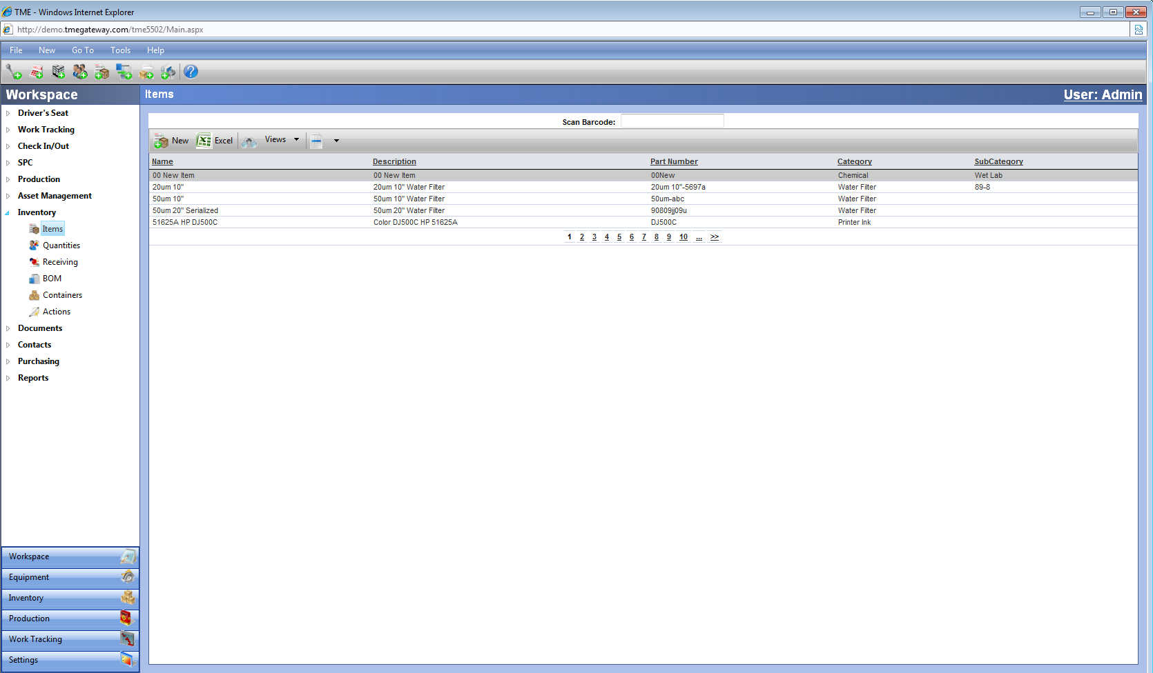
Figure 1 Inventory Items Viewer

Items
The Items submodule contains a table called the Inventory Viewer that displays all of the parts, materials and products that have been entered into TME. It can be accessed via Go To from the Task Bar or from the Inventory Module within a Menu Group. The data can be searched and sorted in order to easily access a specific record.

Exercise 1:
 Add three Inventory Items—one standard, one serialized and one Kit.

- Go to Inventory > Items
- Click on

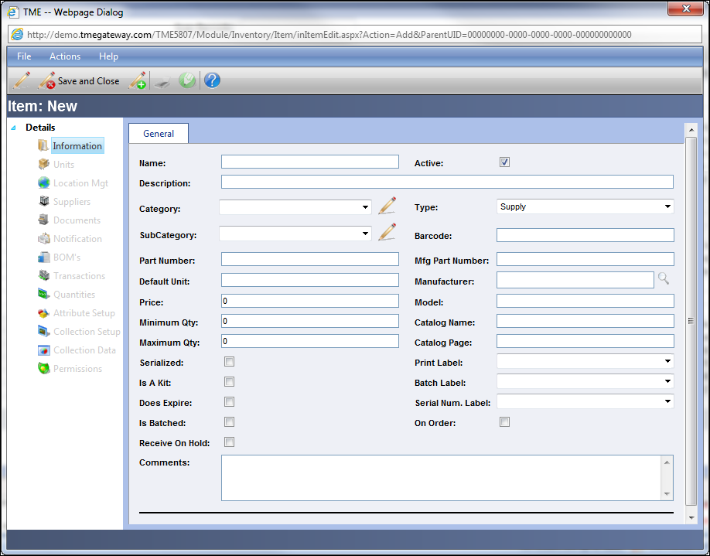
Figure 2 Inventory Item Detail Screen

- Enter/select information for all the applicable fields.
  - The Barcode can be scanned in by clicking in the Barcode field and scanning the barcode of the item
  - Select the Type (hardcoded selections of Product, Material or Supply )
  - Select the Print Label (label for the Item itself), Batch and Serial Number Labels to be used.
  - Check off the checkboxes accordingly: whether the item is Active in the system, Serialized (and therefore will only have transactions based in individual units with serial numbers), On Order (this is an FYI checkbox that needs to be selected and deselected as the status changes), a Kit (will be comprised of other Inventory Items), whether the Item does have an expiration and if a Batch number is required for all quantities of the item and if it must be placed on hold upon receipt
  - If the Item is a Kit, click on to select the BOM which contains the list of Inventory Items that comprise the Kit. Click on the adjacent to the BOM to be selected. The link to that BOM will replace .
- Save. The additional links will now be available when opening this record.
- The screen has changed and has added action items and links.

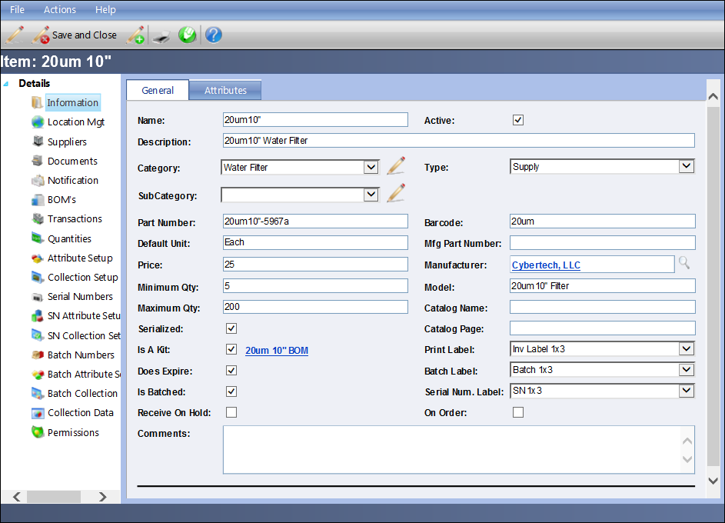
Figure 3 Inventory Item Detail Screen Filled In

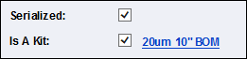
Figure 4 Settings for a serialized Kit Inventory Item

Additional Links for Item Detail Screen

Attributes

Just like Assets, Inventory Items have an unlimited number of Attributes fields available.
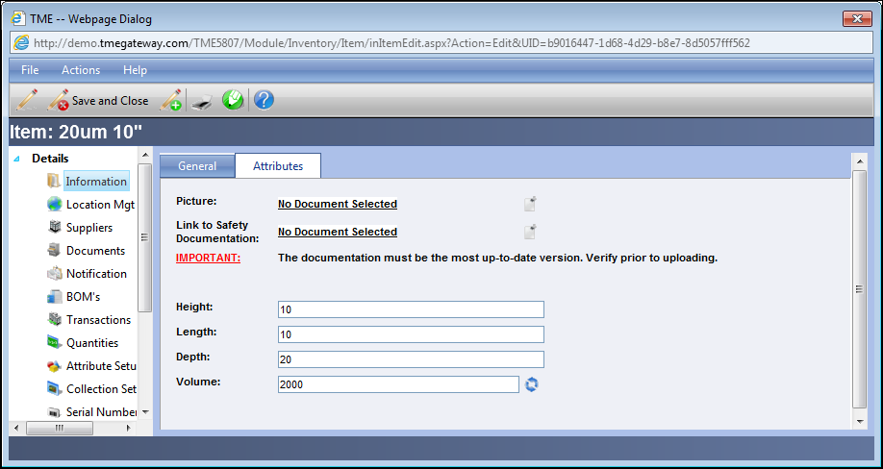
Figure 5 Inventory Item - Attributes Detail Screen

Units

The default unit for an Item is set on the Information link of the Details screen. However, additional units may be set up so that transactions can be placed in terms of these alternate units. For example, the default unit is "Each" with additional units of "Box" consisting of 4 each and "Case" consisting of 12 each. To set up the Units, click on the Units link on the Item's Detail Screen.
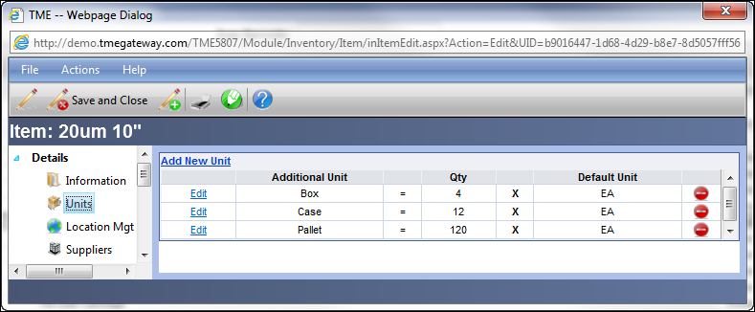
Figure 6 Inventory Item - Units Detail Screen
To add a Unit, click on . Type-in a unit name and Qty and click to save or to close without saving. The (to delete the unit) becomes available after a user exits from and returns to the Units screen. To change a Unit, click on to the left of the Unit name and make the changes.

Location Management

Inventory Item transactions can take place anywhere for any Item as long as the Location itself is setup in the System as an Inventory location. However, to activate notifications for below minimum quantities for a specific location, that location needs to be tied to the Item and the minimum and maximum identified. To set up the Location, click on the Location Mgt link on the Item's Detail Screen.

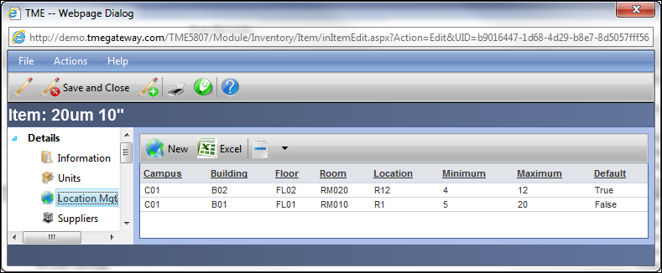
Figure 7 Inventory Item - Location Management Viewer

Adding a new location follows the same format as with other standard viewers. Select the location, add a minimum and maximum number of Items for that location, click on the Default checkbox if the Location is to serve as the Default and save. The Default location is the one to where the Item will be automatically received within the Receiving module.

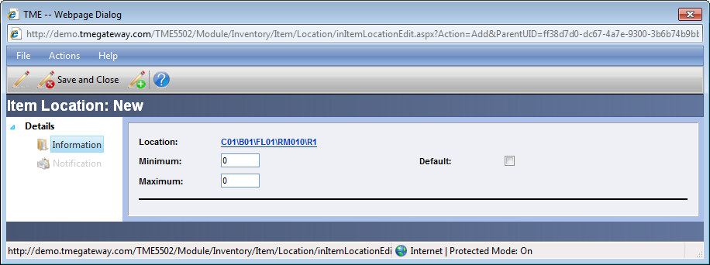
Figure 8 Item Location Detail Screen

Click on the Notification link to select which User or Email Group will get notified via email when the Item goes below the minimum or above the maximum for that Location.

Exercise 2:
Add two units and two locations with minimums of five and maximums of ten to the inventory item. Set yourself up to be notified when Items falls below minimum or above maximum.

Suppliers
The Suppliers viewer lists those companies that supply the Inventory Item. In addition, the price that is set up will flow into a Requisition or Purchase Order should the Supplier be selected for the Item. To set up the Suppliers, click on the Suppliers link on the Item's Detail Screen.
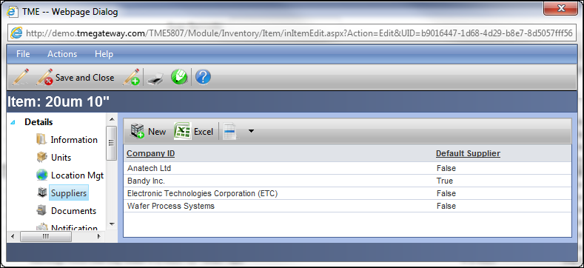
Figure 9 Inventory Item Suppliers Viewer
Suppliers can be added by clicking on . Select the Company ID and if applicable, a Contact. Click the checkbox for Default Supplier if this Company is the default supplier of the Item.
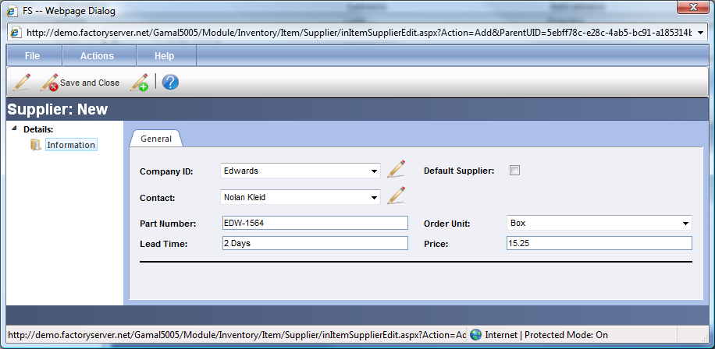
Figure 10 Inventory Item Supplier Detail Screen
If the Company ID is not available, click on to the right of the Company ID field and type in the ID of the new Company. To add a Contact to either an established Company or a new one, click on to the right of the Contact field and type in a new Contact. Newly added Companies and Contacts from this screen will be added to the Contact module accordingly (but will still need the additional information such as phone, address, etc. added via the Contacts module).
Type in the Part Number and Lead Time as appropriate. Select the Order Unit (the units used to place an order and receive) and type in the price per each of those units and Save.

Documents
Documents such as manuals and warranty information can be attached to an Inventory Item. These documents were added to the system per the process in Chapter 3: Contacts and Documents. To associate Documents, click on the Documents link on the Item's Detail Screen.

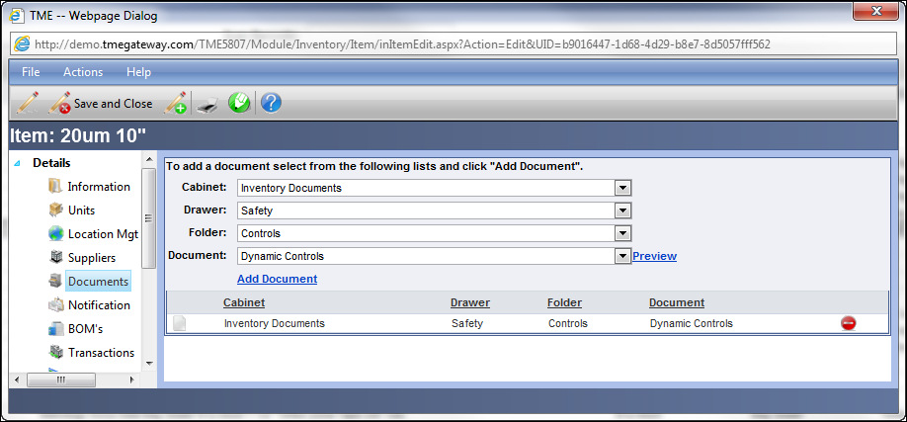
Figure 11 Inventory Item - Documents Detail Screen

Exercise 3:
Add three suppliers to the inventory item and attach two documents.

Notification
The Inventory Item Notification is used to send an e-mail to a User when the minimum or maximum level for the overall quantity has been met. If you put yourself in the notification list, you will receive an e-mail every time the quantity hits or goes beyond one of those levels. To set up the Notification, click on the Notification link on the Item's Detail Screen. This screen works the same as with the Asset Notifications.
 Make sure your User information
contains a valid e-mail address.

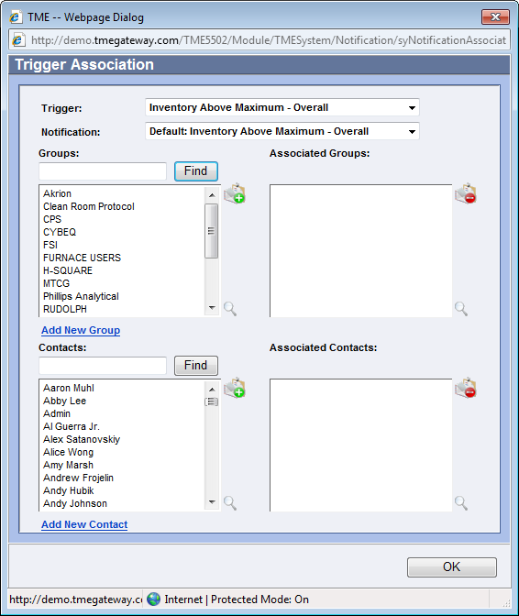
Figure 12 Inventory Item Trigger Association Screen

BOM’s
A Bill of Materials (BOM) is used to group inventory items with a specific quantity onto a list that is then attached to an Asset, Kit, Work Order (Maintenance or WIP) or Scheduled Work. BOM's may be set up with Inventory Items that are typically consumed for a specific preventive maintenance, type of repair or within an Inventory Kit that is used to make a product. It can also be set up to simply be a list of the spare parts and the quantities used for an Asset overall. BOMs set up and used within the WIP process are discussed in the WIP Chapter of this manual.
To add an item to a BOM from within the Inventory Item details screen, click on the BOM's link on the Item's Detail Screen.
Items can be added to a BOM by clicking on the at the left side of the Viewer Toolbar. Click on the BOM: [Name] link and select the BOM to add this Item by clicking on to the left of the BOM name (To add a new BOM, click on at the left side of the Viewer Toolbar. Newly added BOM's will be added to the BOM submodule accordingly). If a BOM is not to be chosen, click the Cancel button or the X at the top right corner of the Item LookUp screen.
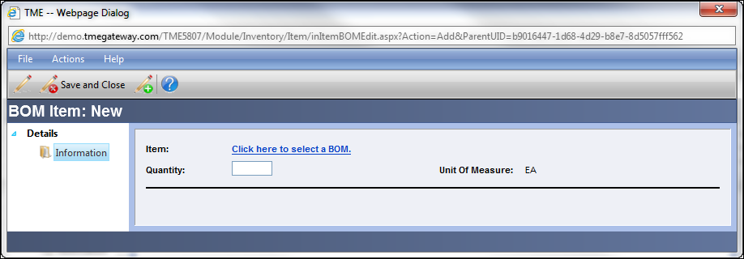
Figure 13 BOM Item Detail Screen
The name of the BOM selected will now appear as the link. Type in the quantity of the Item that is needed for this BOM and Save/Close.
To delete an Item from the BOM, click on to the right of the BOM row.
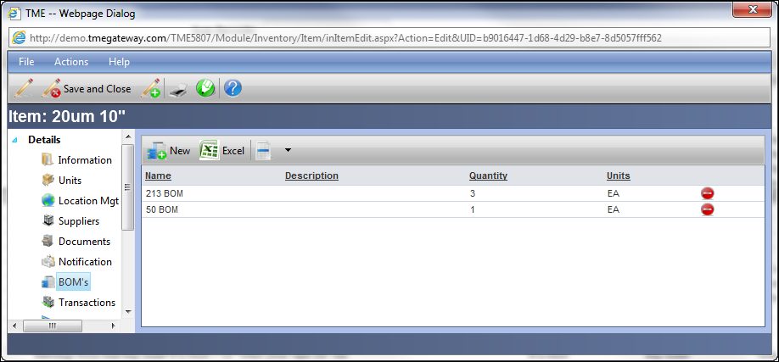
Figure 14 Inventory Item BOM's Viewer

Exercise 4:
Set yourself up for the Notification and include the item in three BOM’s (may need to create new ones).

Transactions and Quantities
The Transactions screen displays a viewer with all of the transactions that have taken place for the Inventory Item. To access, click on the Transactions link on the Item's Detail screen.

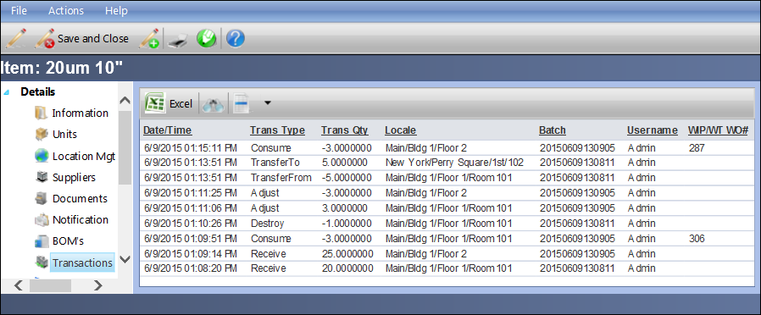
Figure 15 Inventory Item Transactions Viewer

The Quantities screen displays a viewer with all of the quantities at each location that contains the Inventory Item as well as conduct specific transactions directly against that quantity. To access, click on the Quantities link on the Item's Detail screen.

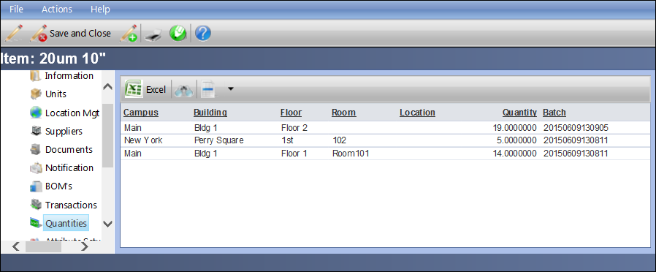
Figure 16 Inventory Item Quantities Viewer

To conduct a transaction directly from the screen, open the record against which the transaction is to take place.

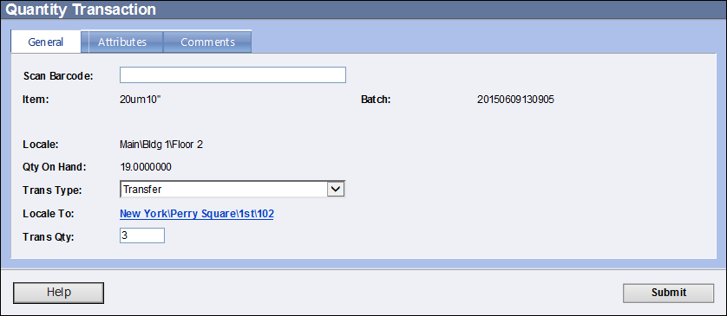
Figure 17 Quantity Transaction Screen

Choose the transaction type, type in the quantity of the transaction and click Submit. If the transaction is to transfer to another locale, then the barcode for that locale can be scanned or the locale can be selected by clicking on the Locale To link.
Consuming or Returning Items against an Asset
can be done either via a Work Order or via the
Inventory Actions submodule, not with the
Quantities transaction screen.

Attribute Setup, Batch Attribute Setup, Serial Number (SN) Attribute Setup
If an Attribute(s) is to be applied to a single Item (or Batch or Serial Number), the attribute is set up on the detail screen via the appropriate Attribute Setup links. The variable groups can be selected and the attribute fields will appear on the Attributes tab on the Information portion of the appropriate detail screen (Item, Batch Number or Serial Number).

Select the Variable Group from the drop-down list. Check the Active box to have the Attributes appear onscreen for the Item. Select the Required Option:

- User Variable Settings: TME will follow the rules set up for the individual variables in the Variable Group; for example, if one or more of the Variables are set up as Required, then entry is required. If they have limits set up, then the entry must be within those limits.
- Data Is Not Required: entry of Attributes is not necessary; for example, if one or more of the Variables are set up as Required, entry is will not required for this Item. If they have limits set up, the entry can still remain blank and the limits ignored.

Run Rules and Notification

Please see the Run Rules Violations Setup portion of Chapter 10: Settings for details.

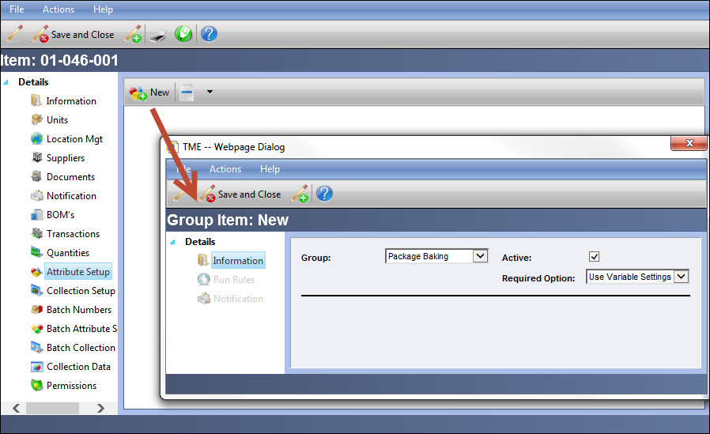
Figure 18 Inventory Item Attribute Setup Screens

Collection Setup

If a Data Collection(s) is to be applied to a single Item (or Batch or Serial Number), the collection is set up on the detail screen via the appropriate Collection Setup link. The variable groups can be selected and the Data Collections will be available for selection for that particular Item. See Chapter 10: Settings for more details.

Batch Numbers
In order to maintain strict genealogy of Inventory Items, batch numbers may be used to track where and when each individual item is received, located and consumed. Batch Numbers are kept in a list with the Inventory Item and are accessed via the various transactions. To access, click on the Batch Numbers link on the Item's Detail screen.
Batch Numbers can be added to the list by clicking on the at the left side of the Viewer Toolbar. Type in the batch number in the text field and if applicable, select an Expiration Date (this is for information only, there are no notifications within the system other than reports once an expiration date has been reached) by clicking on the Open the Calendar popup icon and clicking on a date. If the Batch is to be placed on hold, click on the On Hold checkbox and select the reason for the hold from the Hold Reason drop-down list. Once the Batch is no longer on hold, deselect the On Hold checkbox.
TME may be set up by the Administrator
to automatically place all batched
Items on hold upon receipt. However,
they must be manually deselected from
On Hold.
TME uses the actual Batch Number as the barcode value upon saving the record if no alternate is provided. To add additional barcode value(s), type in the value in the Barcode Values field and click on the Add icon.
Creating a Batch Number does not mean that it exists
as a quantity. It must still be Received or moved into
Inventory from WIP. Most Users will never create a
Batch Number outside of Receiving or WIP.

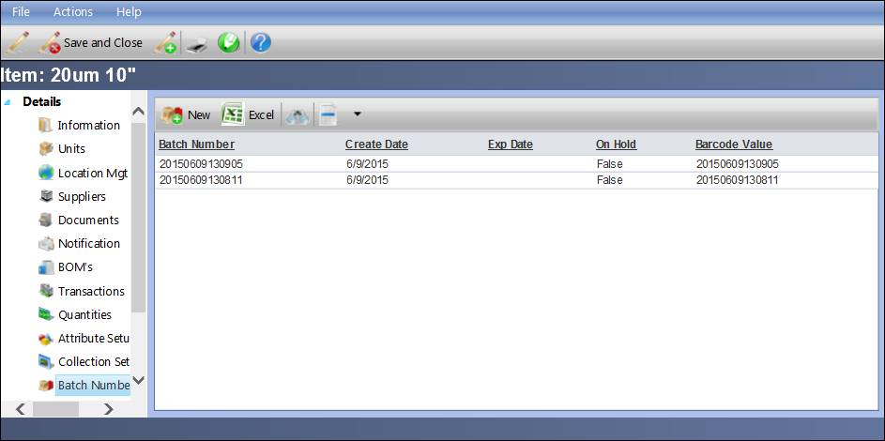
Figure 19 Inventory Item Batch Numbers Viewer

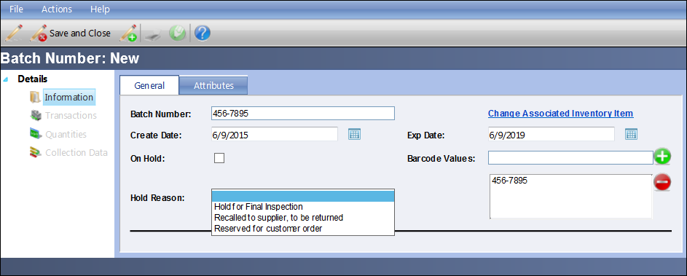
Figure 20 Batch Number Detail Screen

Move Batch Number to Alternate Inventory Item

A Batch Number can be moved from one Inventory Item to another. For example, if a Batch Number was received as the incorrect Item, it can be moved/associated to the correct item rather than scrapped and re-received.

The information (including attributes) for the Batch Number does stay with the original Item—its barcode value(s) is disassociated; there is a transaction “ReassignFrom” in the Batch Number and overall transaction log; and all quantities for the Batch Number are adjusted to zero. The same is true for any Serial Numbers that are associated to the Batch Number—their barcode value(s) is disassociated; there is a transaction “ReassignFrom” in the Serial Number and overall transaction log; and all quantities are adjusted to zero.

The information for the Batch Number and Serial Numbers (if applicable) are replicated to the alternate Inventory Item with the quantities, barcode values, attributes, etc., intact. The Batch Number is now officially reassigned to the alternate Item and all future transactions are logged as such. There is a transaction “ReassignTo” for the Batch Number and Serial Numbers in the appropriate transaction logs.

The history of all transactions prior to this event do remain
with the original Item. It might be necessary to select both
Items when running a transaction report in order to capture
the full history of a batch from receipt to most recent.

To change the Batch Number from one Inventory Item to another, open the Batch Number detail screen. Click on “Change Associated Inventory Item.”

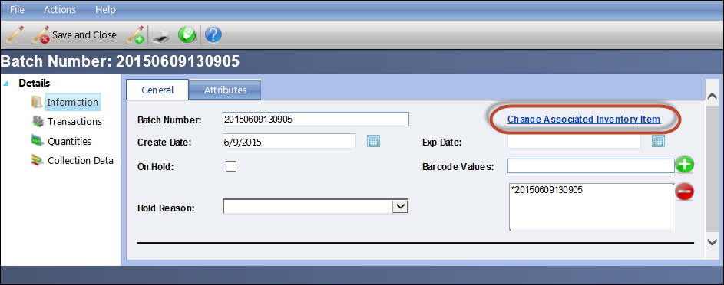
Figure 21 Batch Number Detail Screen - "Change Associated Inventory Item" Link

Click on the LookUp icon to the right of the Product field. Select the Inventory Item by clicking on the corresponding Select icon. Enter transaction comments if applicable and click on the Submit button. The Batch Number and associated Serial Numbers will then be moved and associated to the alternate Inventory Item.

The LookUp screen is automatically filtered to show
only Inventory Items that are defined as “Batched.” If
the current Item is also serialized, then only those Items
that are also serialized will be listed.

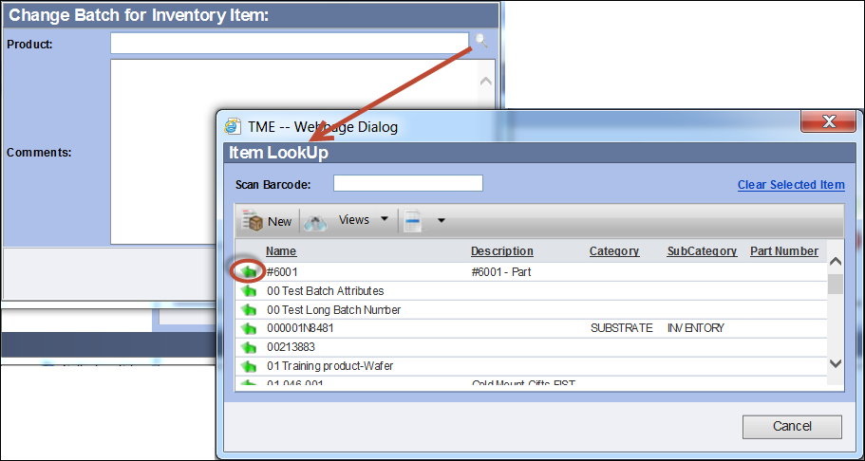
Figure 22 Blank Change Batch for Inventory Item Screen with Item LookUp

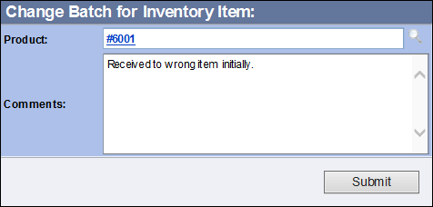
Figure 23 Change Batch for Inventory Items Screen with Entries

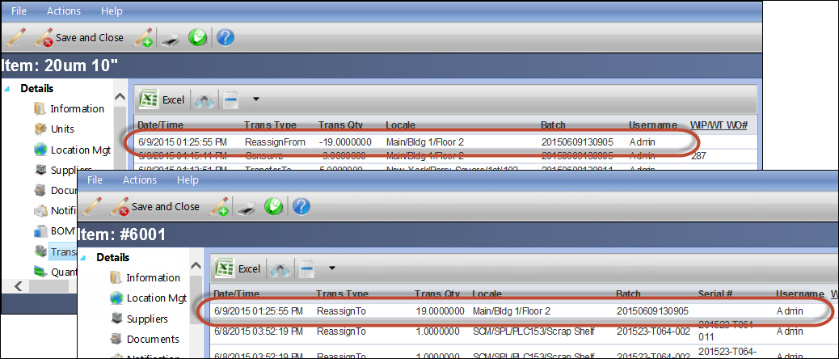
Figure 24 Transaction Screens Showing Reassignment of Batch Number

Serial Numbers
In addition to or instead of utilizing Batch Numbers, serialization may be used to track where and when each individual item is received, located and consumed. To access the list of Serial Numbers, click on the Serial Numbers link on the Item's Detail screen. Serial Numbers can be added to the list by clicking on at the left side of the Viewer Toolbar. Type in the serial number in the text field (or scan barcode into the field).
The Serial Number may be tied to a Batch Number by clicking on to the right of the Batch Number field. The Item LookUp screen will appear and contains the list of Batch Numbers already set for the Item. The Search, Views, Records per Page and Add New (if permission has been provided) functions are available at the top of the screen.
Select the Batch Number (or click within the Scan Barcode field and scan the barcode for the Batch Number; the screen will automatically close and the Batch Number is selected).
If a new Batch Number needs to be created, click on at the left side of the Viewer Toolbar. Save/Close after entering information. This will return you to the Batch Number LookUp screen for selection of the Batch Number. Select the Batch Number. The screen will close and return you to the Serial Number Detail Screen.
TME uses the actual Serial Number as the barcode value upon saving the record if no alternate is provided. To add additional barcode value(s), type in the value in the Serial Number Values field and click on the Add icon.
Creating a Serial Number does not mean that it exists
as a quantity. It must still be Received or moved into
Inventory from WIP. Most Users will never create a Serial
Number outside of Receiving or WIP.
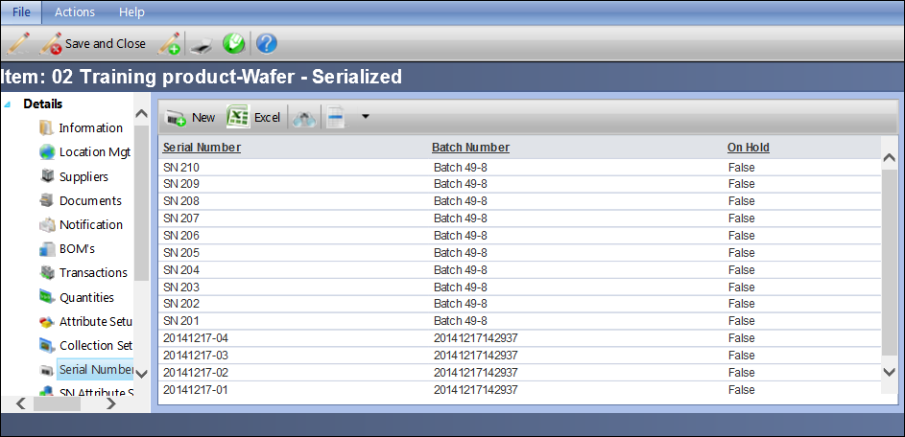
Figure 25 Inventory Item Serial Numbers Viewer
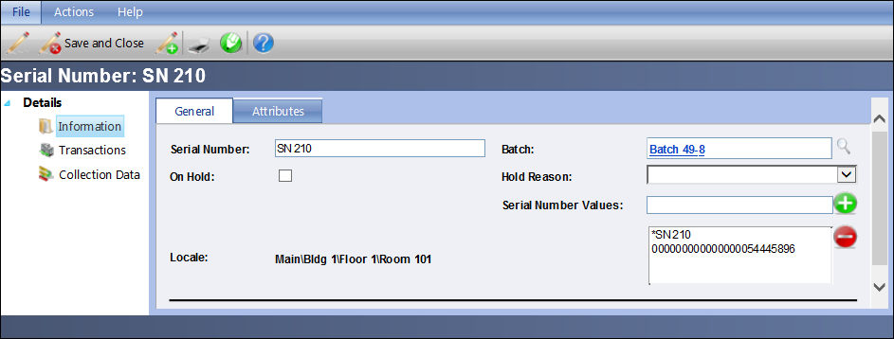
Figure 26 Serial Number Detail Screen
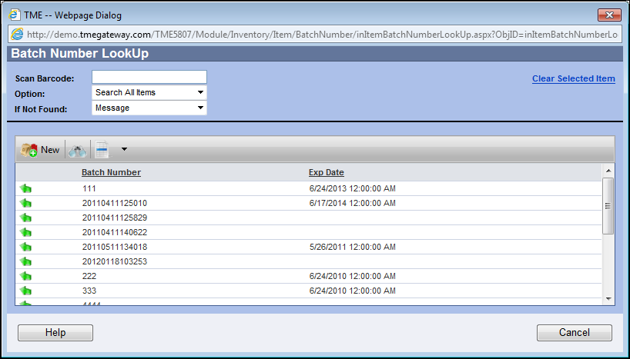
Figure 27 Batch Number LookUp

Collection Data

To view the data that has been collected for an Item (or Batch or Serial Number), click on the Collection Data link on the detail screen of the object. The viewer of all data collection records for that object will appear. Double-click on the record in question to open the detail screen and review/edit the data. If the data is edited, the Modified By and Modified Date fields will update accordingly. The original data will not be retained.

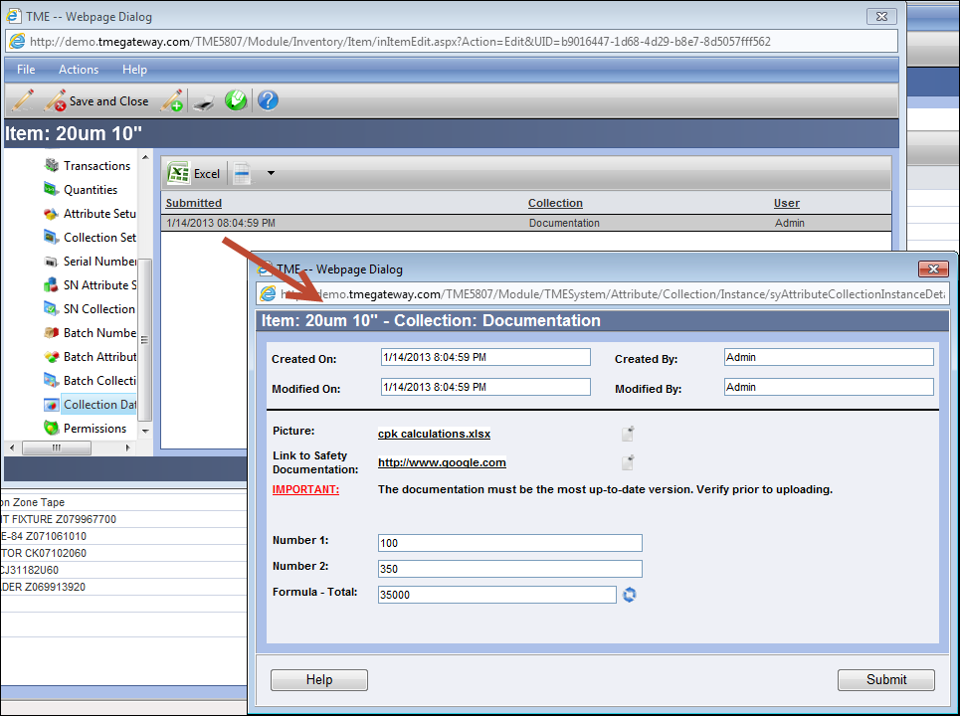
Figure 28 Inventory Item Collection Data Screen
Permissions

Even though you’ve given permission to Groups to have access to the Inventory Items SubModule, restricted permission may be provided for individual Items. The default is set to allow all Groups with permission to the SubModule to have access to every Item. However, your business model might need to restrict certain Groups from certain Items. To set up the Permissions, click on the Permissions link on the Item's Detail screen.

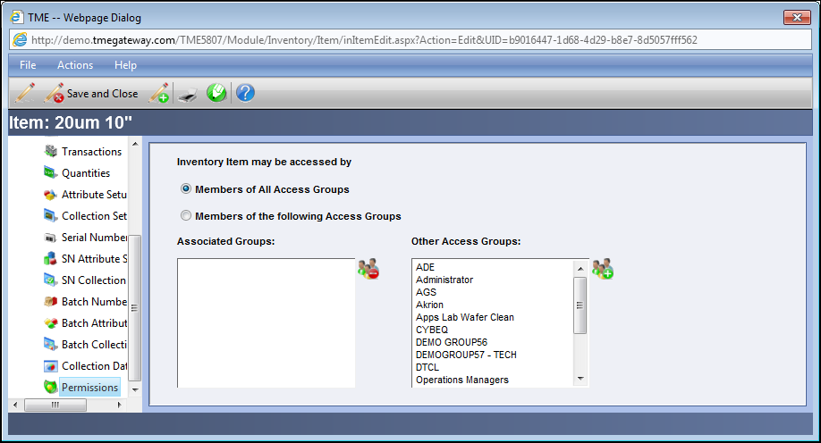
Figure 29 Inventory Item - Permissions Detail Screen

Copying an Inventory Item
Inventory Items can be copied individually by opening the Item’s Detail screen, clicking on Actions on the Toolbar and selecting Generate Copy. The screen will refresh and the Item name will have the addition of “.copy” at the end. The screen is now open to the new Item. The identifying information is copied over: General Information, Attributes, Location Management, Suppliers, Documents, Notification, Attribute Setup (Item, Batch Numbers and Serial Numbers), Collection Setup (Item, Batch Numbers and Serial Numbers), and Permissions. Transactional or distinguishing information is not: Barcode Values, BOM’s, Transactions, Quantities, Data Collections (Item, Batch Numbers and Serial Numbers), Batch Numbers, and Serial Numbers.

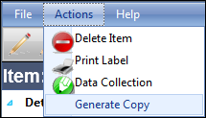
Figure 30 Generate Copy Link

Exercise 5:
Set yourself up for the Permissions of the Item and create two Batch Numbers and three Serial Numbers. Set up one of the Serial Numbers with a Batch Number created via the Batch Number LookUp screen.

Exercise 6:
Print an Inventory Item, Batch Number and Serial Number label for your Item (if printer is not available, save to desktop).

Exercise 7:
Set up a serialized Kit Item with three sets of Units, three locations with minimums and maximums, one supplier, two documents, notification and permissions set for yourself, and five serial numbers each attached to one of two batches.

Quantities
The quantity of items contained in a User’s My Inventory or at a particular Locale are displayed in the Quantities submodule. It can be accessed via Go To from the Task Bar or from the Inventory Module within a Menu Group.
Users are able to transfer Inventory Items to and from themselves as if they are Locations. This allows for the tracking of these items while in transit (a vehicle could be set up as a User) or in a User's workspace prior to actual consumption via a Work Order or an Action within the Inventory Module. Kits are built from Items located in the User’s My Inventory. The User clicks on the My Inventory radial button at the top of the screen to view the list of Items contained in his/her My Inventory.
To view the quantities of all items at any given location, click on the Locale radial and select the location by clicking on the locale link.
Just as with the Quantities screen on the Item Detail screen, certain transactions can be conducted against a particular quantity by opening the record.
Consuming or Returning Items against an Asset
can be done either via a Work Order or via the
Inventory Actions submodule, not with the
Quantities transaction screen.

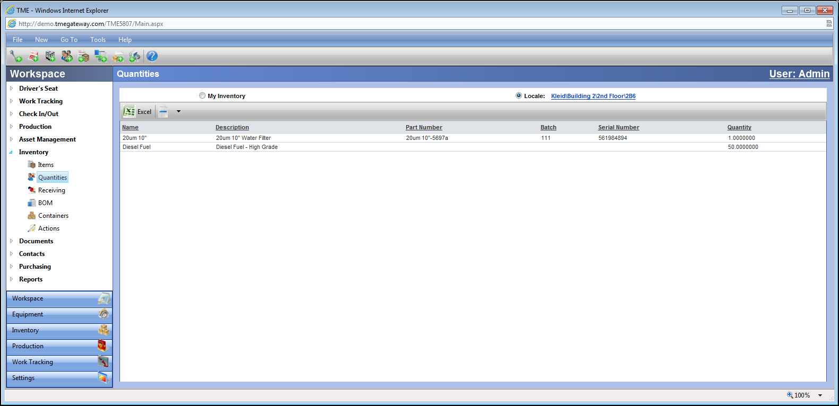
Figure 31 Quantities Viewer

Receiving
The Receiving submodule contains the Receipt Viewer that displays all of the Receiving records for all Inventory Items. It can be accessed via Go To from the Task Bar or from the Inventory Module within a Menu Group. The records are given a Receipt ID and logged by the Location Date (Locations may be in a different time zone than the server where the application is hosted; the date on the viewer is based on the time of the location where the Inventory Items were received) upon being saved the first time.
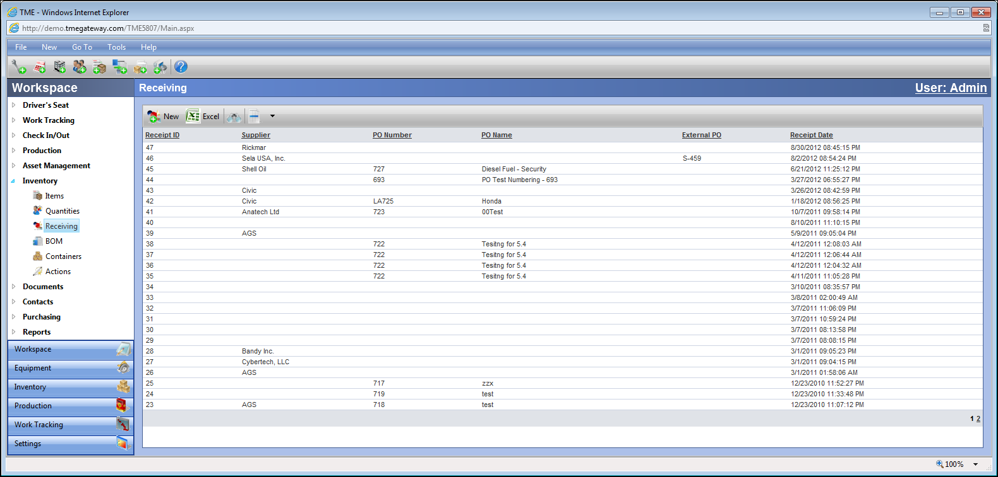
Figure 32 Receiving Viewer

Receiving Items Without a Purchase Order
Inventory Items can be received by clicking on at the left side of the Viewer toolbar.
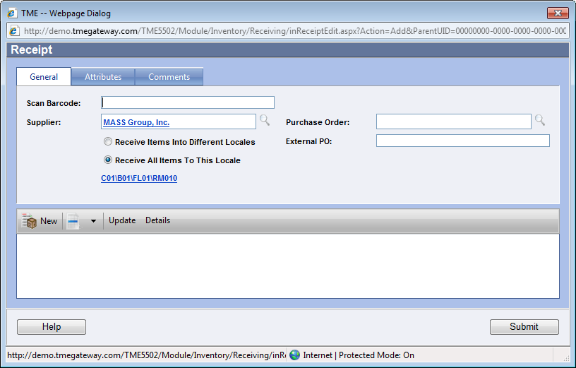
Figure 33 Receipt Detail Screen
Use the Scan Barcode field to upload the Supplier by scanning the Supplier barcode value (is part of the Companies profile on its detail screen in the Companies submodule).
If the barcode value is unknown or doesn’t exist, select the Supplier from whom the Inventory Items were received by clicking on to the right of the Supplier field. A popup screen representing the Company Viewer will appear. Click on to the left of the Company ID (To add a new Company, click on at the left side of the Viewer Toolbar. Newly added Companies will be added to the Companies submodule accordingly). Once selected, the Company ID will populate the field as a link. Clicking on the link will bring up the Company Detail screen.
Select either "Receive Items Into Different Locales" or "Receive All Items To This Locale." The Locale link will appear if the Items are to be received into the same locale (otherwise each item upon selection will have the Locale link available). Click on the Locale link and the Select Locale popup will appear. Select the locale accordingly.
If an external Purchase Order Number has been provided, type that number into the External PO field.
Adding Inventory Items to a Receipt
Click on on the left side of the viewer located at the bottom of the Receipt screen.
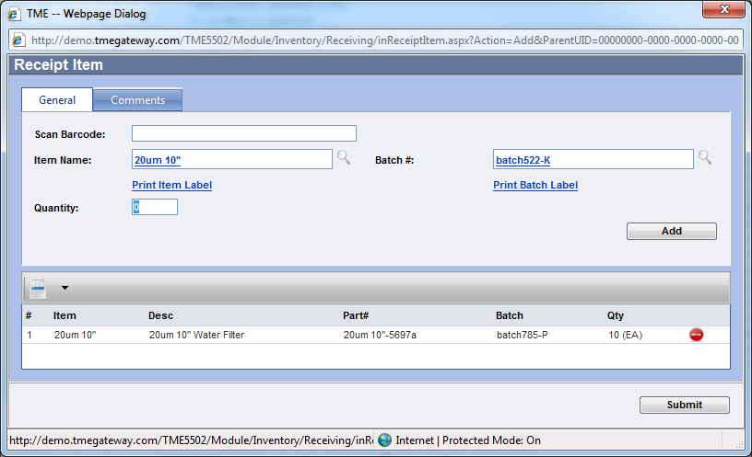
Figure 34 Receipt Item Detail Screen
Use the Scan Barcode field to upload the item. If the barcode is unknown or doesn’t exist, select the Item via the Item LookUp screen (click on to the right of the Item Name field), type in the Quantity and select the proper Unit of measure.
If the Item requires a Batch Number, click the the Batch Number LookUp icon and scan that value via the Scan Barcode field, select an already existing Batch Number, create a new Batch Number by clicking on the New Batch Number icon, or create an automatically generated number using a date time stamp by clicking on Auto Generate New.
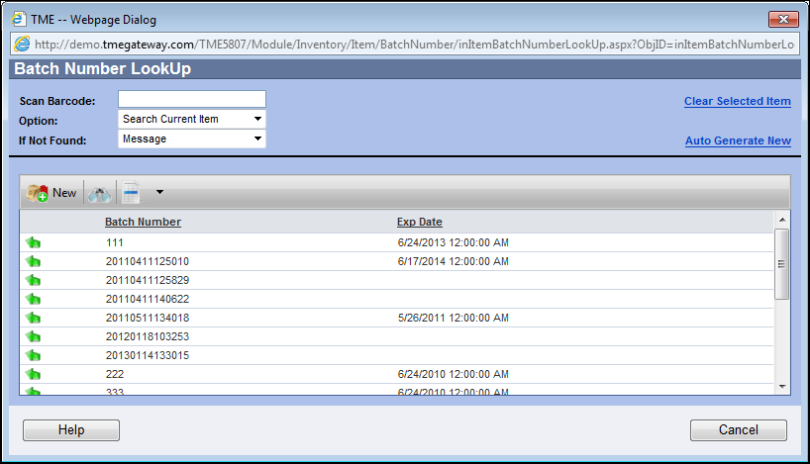
Figure 35 Batch Number LookUp Screen
If the Item is serialized, click on the Serial Numbers link which appears once the Item has been selected. The Serial Numbers screen appears. Type in the first serial number and click enter or on or scan (click within the top field and scan) the serial number. Continue to enter all the serial numbers in the same manner. If a serial number is incorrectly included, select it from the list and click on . Click on the Submit button. The Serial Numbers link will now have the number of serial numbers that were entered in parentheses.
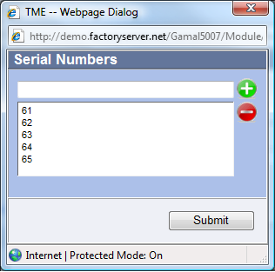
Figure 36 Input of Serial Numbers into Receipt Screen
If the Labels for this Receipt Item is needed, click , and/or .
Click Submit and this item will be added to the Item Viewer at the bottom of the Receipt screen. Repeat to add additional items. Click on located on the right side of an Item row to delete that record.
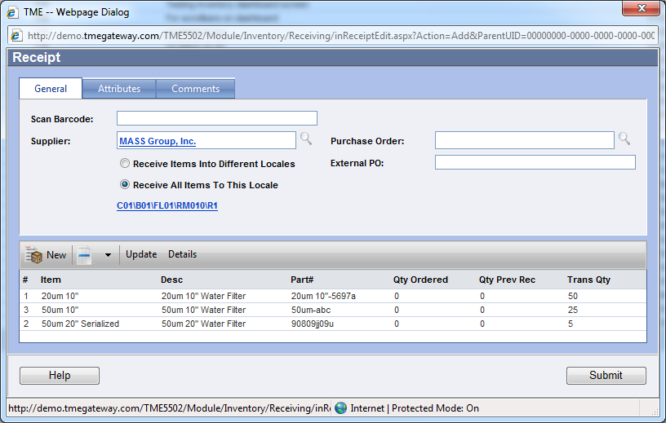
Figure 37 Receipt Detail Screen with Items Added

Selecting Attributes for a Receipt
Click on the Attributes tab. The attribute fields have been predefined by the TME Administrator. Some of the Attributes may have default values already populated. Enter/edit the Attributes accordingly.
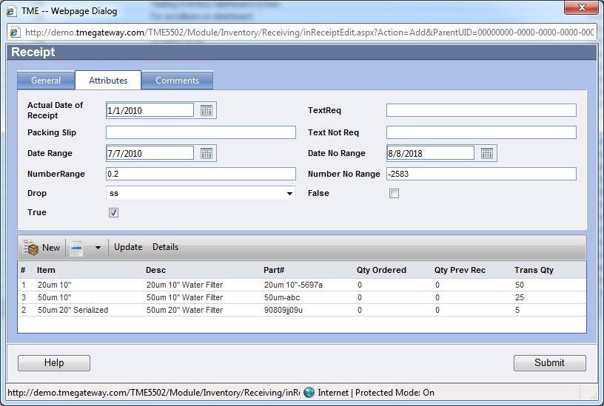
Figure 38 Receipt Attributes
Adding Comments to a Receipt
Click on the Comments tab and type in the Comments into the text field.
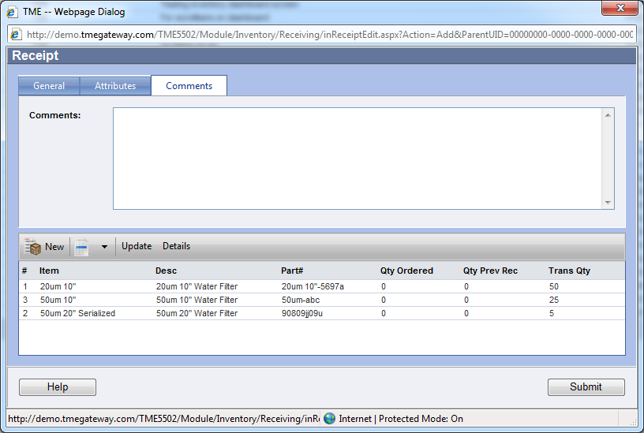
Figure 39 Receipt Comments

Submit a Receipt
From either the General, Attributes or the Comments tab, click on the Submit button after all Inventory Items have been added. The Receipt will be given the next available Receipt ID and added to the Receiving viewer.
Provided the TME Administrator has selected the option for printing receipts, a Receipt will open up as a pdf file for printing. To reprint a receipt at any time, double-click on it to open and then resubmit.
To edit a receipt, double click on it. A popup message appears: "You may edit this receipt for record keeping purposes only. Any changes made to this receipt will not affect inventory quantities and/or locations." Click the OK button to continue. Make any edits as necessary on the General, Attributes or Comments tabs and click the Submit button--as stated with the popup, changes will not affect the transactions or quantities that have been recorded, only the receipt is edited. An audit trail showing updates to the details of the Receipt from the time the record was created is available by returning to the Receipt Detail screen and clicking on the Audit Trail tab.
Receipts cannot be deleted.

Receiving Items With a Purchase Order
The Scan Barcode field utilizes the universal bar-coding feature of TME. Automatically populate the Purchase Order and Supplier fields by scanning the barcode of the Purchase Order. If barcode is not available, select the Purchase Order number by clicking on the "Click here to look up" icon to the right of the Purchase Order field. A popup screen representing the Purchase Order Viewer will appear. Click on the Select Item icon to the left of the Purchase Order ID (To add a new Purchase Order, click on the New icon at the left side of the Viewer Toolbar. Newly added Purchase Orders that have been released to the supplier will be added to the Purchase Orders submodule accordingly). If a Purchase Order is not to be chosen, click the Cancel button or the X at the top right corner of the Item LookUp screen. Once selected, the items from the Purchase Order will populate the Items portion of the receipt and the Purchase Order ID and Supplier will populate the appropriate fields as links to their respective Detail screens.
If an external Purchase Order Number has been provided, type that number into the External PO field.
Items requiring batch or serial numbers will have the icon visible. The receipt will not submit until the information needed has been provided or the quantity changed to zero.

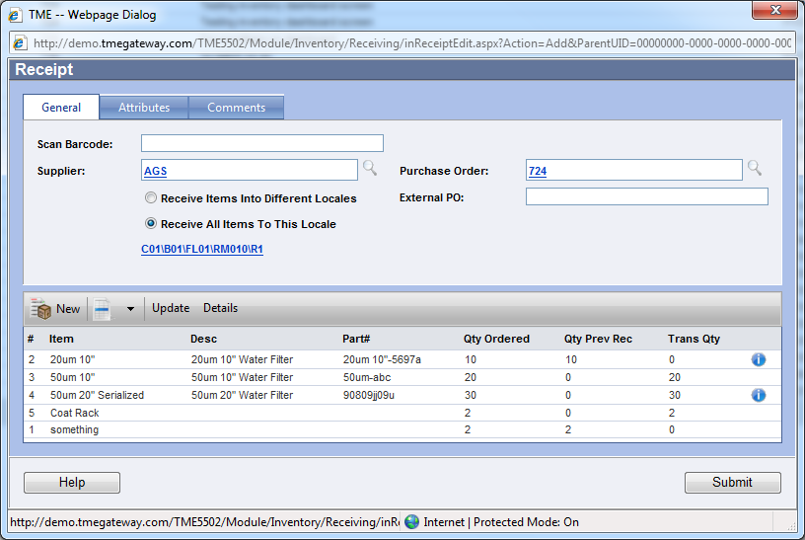
Figure 40 Receipt with Selection of Purchase Order

Update the quantities, Batch Numbers, Serial Numbers and or Locale via either the Update or Details function.
To update utilizing barcode scanning of the Items listed (critical for submitting multiple batches of a single Item or to add additional items not on the Purchase Order): click on the Update button on the toolbar. Utilize the Scan Barcode field as described for adding new items to the list to update the particular item. Update the quantity by typing in the value. Click on the Add button to add to the list. For Items with multiple batch numbers--repeat process for each batch number. The total quantity received will be the sum of the quantity of each batch. To print the Item or Batch labels, click on the appropriate link and the label will appear in a pdf file for printing. Click on the Comments tab to add additional information. Click on Submit when finished. The full list will refresh to include the updates. Not all Items need to be updated--if no batch number, serial number or change to the locale or quantity needs to be made, then they will be received as such.
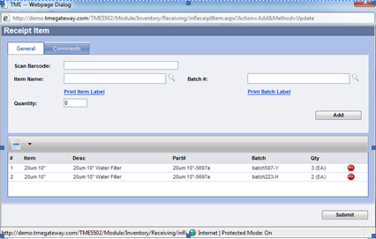
Figure 41 Receipt Item Detail Screen

To update by selecting Items from the list as populated by the Purchase Order (or just to view the locales set for each Item): click on the Details link on the toolbar. Double click on the appropriate Item or right click and select View to open the Receipt Item screen. Utilize the Scan Barcode field as described for adding batch numbers or changing the locale for the particular item. Update the quantity by typing in the value. To print the Item or Batch labels, click on the appropriate link and the label will appear in a pdf file for printing. Click on the Comments tab to add additional information.
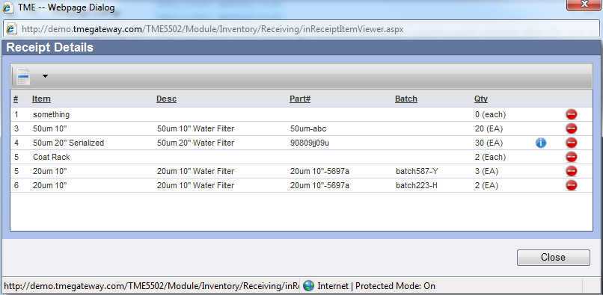
Figure 42 Receipt Details Screens

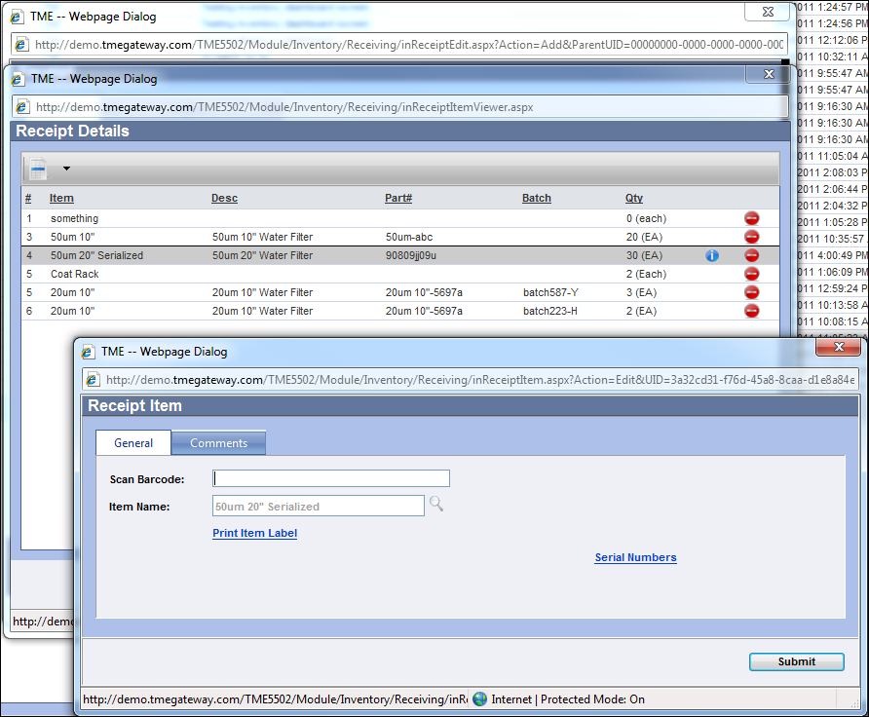
Figure 43 Receipt Item Detail Update Screen
To remove an item from the list (and therefore the receipt), click on the Remove icon or right click and then Delete for the Item and then click OK on the "Are you sure you want to remove this item?" message. Click on Submit when finished. The full list will refresh to include the updates. Not all Items need to be updated--if no batch number, serial number or change to the locale or quantity needs to be made, then they will be received as such.

Exercise 8:
Receive each of your three inventory items with a single supplier to a single location. Use Batch Numbers for each Item and Serial Numbers accordingly.

Exercise 9:
Receive each of your three inventory items with a single supplier to multiple locations—two locations per item. Use Batch Numbers for each Item and Serial Numbers accordingly.

Exercise 10:
Receive each of your three inventory items with different suppliers to multiple locations—each Item in a different location. Use Batch Numbers for each Item and Serial Numbers accordingly.

Bill of Materials (BOM)
The BOM Viewer lists the Bills of Material entered into TME. It can be accessed via Go To from the Task Bar or from the Inventory Module within a Menu Group.
New BOM's can be added by clicking at the left side of the Viewer Toolbar. Type in the details--Name (required), Description, and Notes. Check off the checkbox whether the item is Active in the system. Save.
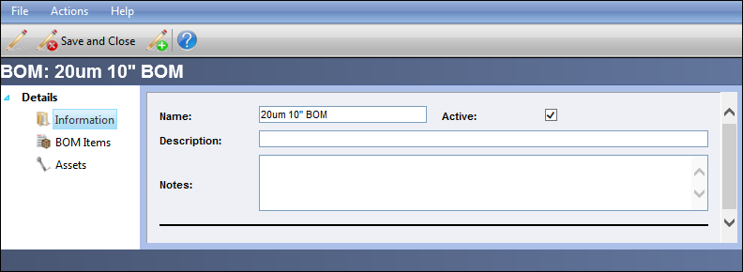
Figure 44 BOM Detail Screen

Items can be added to a BOM by clicking on the BOM Items link on the BOM Detail screen. Click on on the viewer toolbar. Select the Inventory Item via the Item LookUp. Type in the Quantity that this BOM will need. Check the Required box if this item’s use is mandatory for this BOM. Check Can Exceed if more quantity can be consumed than is set on this screen. Select the Unit of Measure.
The next section of the screen is for setting the default Locale and Batch Number from which the User can auto consume when in WIP. Once the quantity of the batch at that locale has been used up, alternate locales and/or Batch Numbers will need to be selected for the next set of WIP Work Orders. Auto consume only works in WIP and is further discussed in the WIP Processing chapter.
Save/Close.
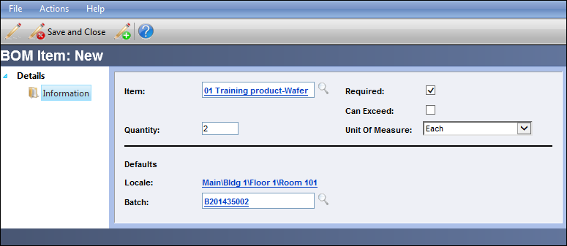
Figure 45 BOM Item Detail Screen
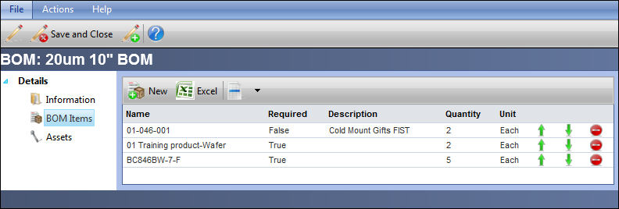
Figure 46 BOM - BOM Items Viewer

Add and delete Inventory Items as needed. The sequence of the Items may be changed by clicking on the or accordingly.

Linking a BOM to an Asset
BOM's can be linked to an Asset either via the Asset Details screen or via the BOM detail screen. From the BOM detail screen, click on the Assets additional link.
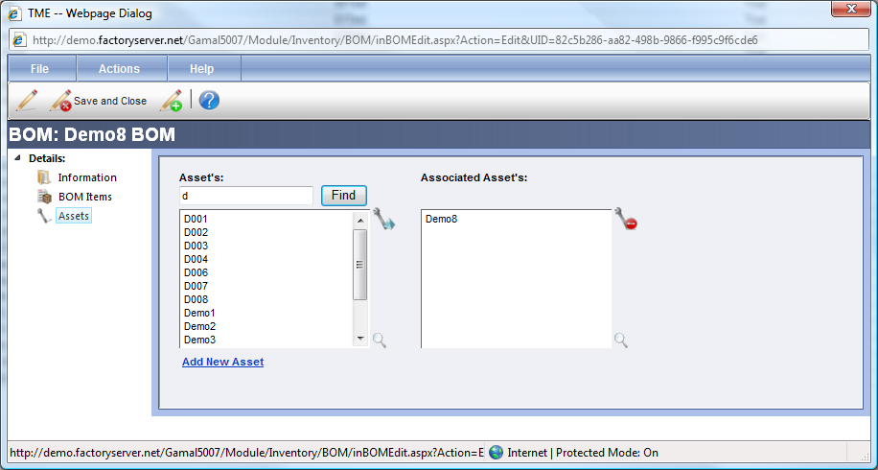
Figure 47 BOM - Asset Association Detail Screen
To search for an Asset, type in the ID (or partial begining) of the Asset in the blank field and click on the Find button. The list of Assets will populate with the Assets accordingly. Select the Asset (click Ctrl on the keyboard and select additional Assets to make multiple selections) and click on the Add Asset icon . The Assets will be listed in the Associated Assets field. To remove an Asset from the Associated Assets field, select the Asset(s) and click on the Remove Asset icon .
To view the Asset detail screen, select the Asset and click on . The Asset Details screen will appear.
To add a new Asset to be available for selection, click on . Once the new Asset is saved, it will be added to the list of Assets and available for selection.

Exercise 11:
Set up three BOMs utilizing a combination of your three Items and two Items set up by another User. Link each BOM to two Assets. Verify the linkage via the Assets’ detail screens.

Actions
Numerous types of transactions can take place with Inventory Items. Items can be consumed, moved, scrapped and built into kits (Items and Products used within WIP are discussed in the WIP Chapter of this manual). These transactions take place in the Actions submodule which can be accessed via Go To from the Task Bar or from the Inventory Module within a Menu Group.

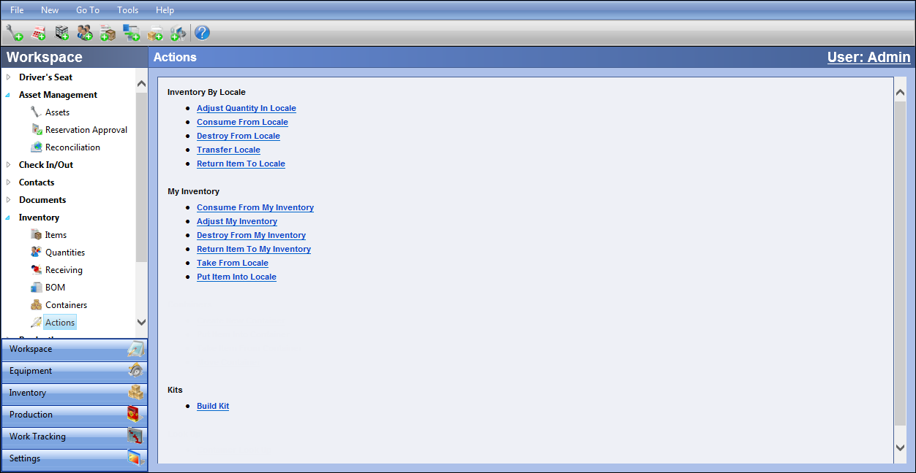
Figure 48 Actions Screen

Inventory by Locale Actions
To adjust (reconcile) the quantity of an item in a particular location, click on .
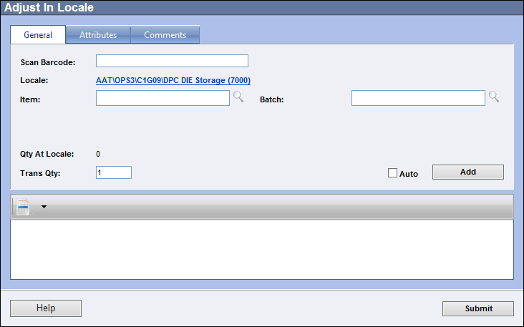
Figure 49 Adjust Quantity Transaction Screen
The Adjust Quantity screen will appear. Select the Locale, Item and if applicable, the Batch Number to be adjusted. Serialized Inventory Items cannot be adjusted as they will always have a quantity of one or zero (can receive to add to quantity and consume or destroy to delete). Type in the Trans Quantity (the new Quantity).
Click on the Attributes tab to enter attribute information for the entire transaction.
Click on the Comments tab to enter comments for the entire transaction.
Click on the Add button to add the Item count to the list. Repeat for all Items counted in the Locale. The Locale can be changed and additional Item counts added to the list.
From any of the tabs, click on the Submit button to process the transaction or click on the X at the top right corner of the screen to cancel. The screen will disappear and the transaction is logged in the Transactions screen accessed via the link on the Item Detail screen.
To verify that the adjustment took place correctly, click on the Quantities link on the Item's Detail screen. The screen will show all of the quantities for the Item for any given location (User name will be listed in the Location column if located in a User's My Inventory) where the quantity is not zero.
Selecting Serial Numbers for Actions other than Adjust
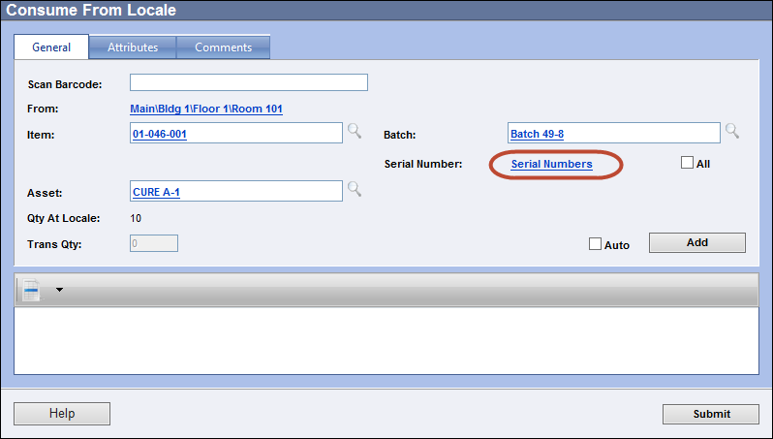
Figure 50 Consume Quantity Transaction Screen

To select the Serial Number(s) on a transaction screen, click on or select the All checkbox to select all of the Serial Numbers for the selected Item/Batch Number.
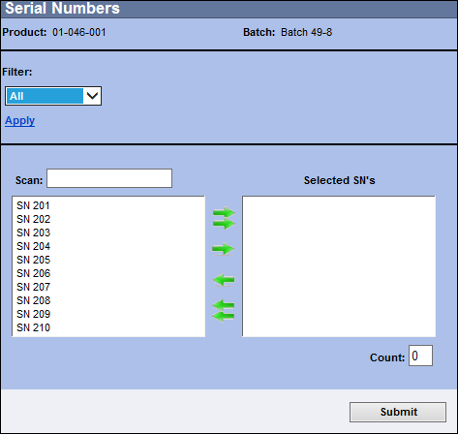
Figure 51 Serial Number Selection Screen

The Serial Numbers screen will only show those for the combination of the selected Product and Batch Number.

The numbers can be filtered using the Filter drop-down criteria and the Apply link.

If the serial number barcode is available, click into the Scan field and scan the barcode (or type and hit the Enter key). This will select the serial number and place it into the Selected SN’s column. Repeat as needed.

If not using barcoding, click on the Serial Number (use the Alt key and click on multiple numbers to select more than one; or the shift key to select all between two selected numbers) and then to move it to the Selected SN’s column.

To move all of the Serial Numbers, just click on . The count field will show the quantity of numbers selected. Click Submit when ready. The Items will be ready to add to the list.
Click on the Add button to add the Item count to the list. Repeat for all Items to be Consumed from the Locale. The Locale can be changed and additional Items can be added to the list (they do not all have to have batch and/or serial numbers to be on the same list).

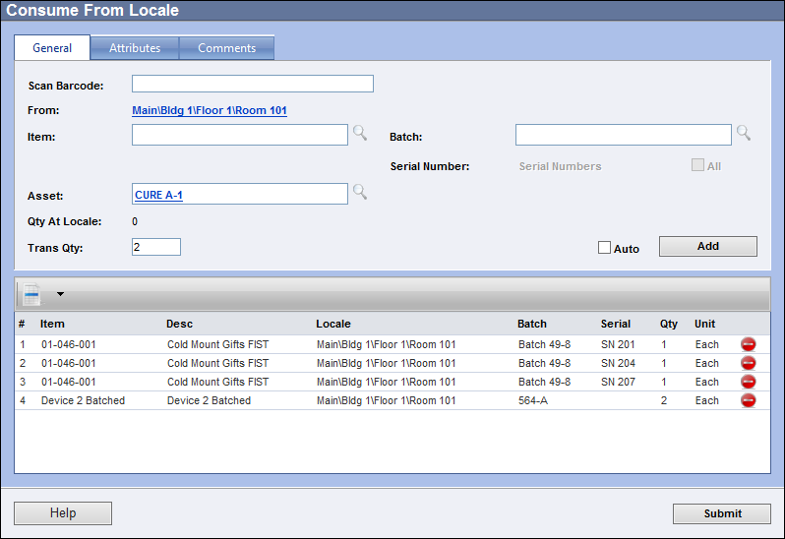
Figure 52 Populated Consume from Locale List

If transactions are in quantities of “1,” select the Auto
checkbox. TME will automatically add a quantity of one Item
to the list as it is selected and proper information (Batch
and/or Serial Number) is provided.
All of the transactions use the same screen with possible minor differences.
- Adjust from Locale: adjusts the quantities of Items at selected Locale, can have Batch Numbers, but no Serial Numbers as those are always counts of “1.”
- Consume from Locale: consumes quantity of Items from a selected Locale; can consume directly from Locale to track overall consumable costs or can consume to an Asset and be able to report on consumable costs for the Asset
- Destroy from Locale: removes quantity of Items from Inventory
- Transfer Locale: transfers quantity of Items from one Locale to another; has additional “To:” field for the selection of the Locale to where the Items are going
- Return Item to Locale: is for returning a quantity of an Item that may have been inadvertently destroyed or consumed and was removed from inventory or a quantity of Item that has simply been found and had never been entered into inventory to a Locale; does have Asset field available if returning an Item that had been Consumed to an Asset (to subtract cost from total consumable cost for the Asset)
The Consume and Return actions are the only transactions
that can be done directly against an Asset.

My Inventory Actions
These transactions work in the same manner as those by Locale and the screens are identical, but they are against Inventory Items that are in a User’s “My Inventory”. On a Quantities screen or in a report, the quantity is not located at a Locale. The entry in the Location field is the name of the User.
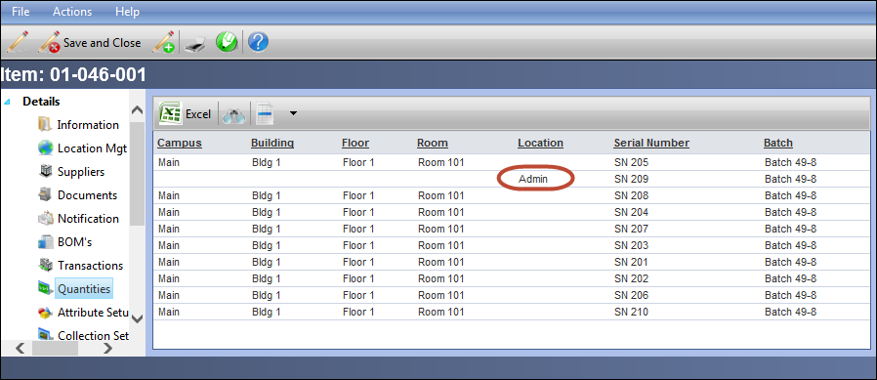
Figure 53 User Name in Place of Location on Item Quantities Screen

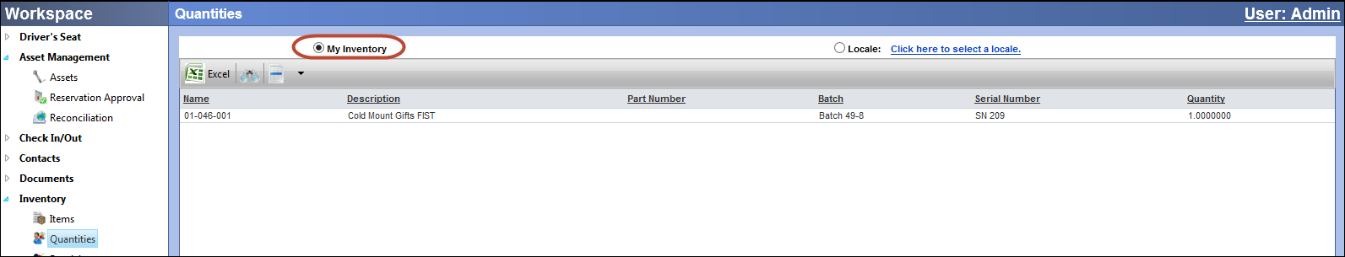
Figure 54 My Inventory Quantities Screen

- Consume from My Inventory: consumes quantity of Items from My Inventory for the logged in User; can consume directly to track overall consumable costs or can consume to an Asset and be able to report on consumable costs for the Asset
- Adjust from My Inventory: adjusts the quantities of Items already in My Inventory for the logged in User, can have Batch Numbers, but no Serial Numbers as those are always counts of “1.”
- Destroy from My Inventory: removes quantity of Items from My Inventory for the logged in User and Inventory entirely
- Return Item to My Inventory: is for returning a quantity of an Item that may have been inadvertently destroyed or consumed and was removed from inventory or a quantity of Item that has simply been found and had never been entered into inventory to My Inventory of the logged inUser; does have Asset field available if returning an Item that had been Consumed to an Asset (to subtract cost from total consumable cost for the Asset)
- Take from Locale: takes a quantity of Items from a selected Locale and places it into the My Inventory of the logged in User
- Put Item Into Locale: takes a quantity of Items from My Inventory of the logged in User and places it into a selected Locale

Kits Actions
Inventory Items can be put together as Kits for consumption within a work order, distribution to different locales, as a final product that is sold (not via WIP), etc. Once Items are built into a kit, the quantities used are no longer included in the Items' quantities. The Items from that point on are tracked as part of the Kit. Instead of a User consuming multiple Items, he/she can consume a single Kit.
To build a Kit, click on .
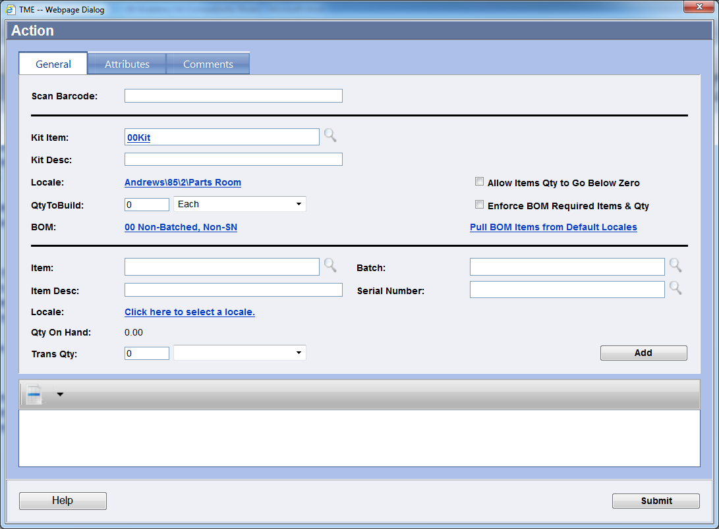
Figure 55 Build Kit Transaction Screen
The Build Kit screen will appear.
The following options are available:
- Allow Items Qty to Go Below Zero – system will not prevent the build if the quantity of Items consumed goes below zero for the selected locale
- Enforce BOM Required Items & Qty – system will prevent build if all Items that have been designated as “Required” on the BOM have not been added to the Build list
- Pull BOM Items from Default Locales – this link will only appear if all Items on the Kit’s BOM are not serialized or batched. Click on this link to automatically populate the Build list with the BOM Items using their default Locales and calculations of the Qty based on number of Kits to build and the number of Items set per BOM.
- Attributes tab – if Attributes are available, enter values accordingly at any time prior to Submittal. These will be linked to the transaction, not the Kit
- Comments tab – add Comments any time before submittal. These will be linked to the transaction, not the Kit
Scan or select the Product (Kit) to be built (same method as selecting an Inventory Item for individual transactions). The Kit Desc will populate with the Kit’s Item Description and the Locale will populate with the default locale for the Kit (set up via the Location Management link on the Item Detail screen). If the Locale needs to be changed, click on the locale string link to open the Select Locale screen. If applicable, scan or select the Batch Number and/or Serial Number to be assigned. The BOM will populate with a link to the Bill of Material associated with the Kit. Click on it to view the BOM and access the list of Items. Type in the quantity of Kits to be built. If the Kit is to have a serial number, only one Kit can be built at a time.
If using the Pull BOM Items from Default Locales option:
Click on this link to automatically populate the Build list with the BOM Items using their default Locales and calculations of the Qty based on number of Kits to build and the number of Items set per BOM. Click on to complete the build.
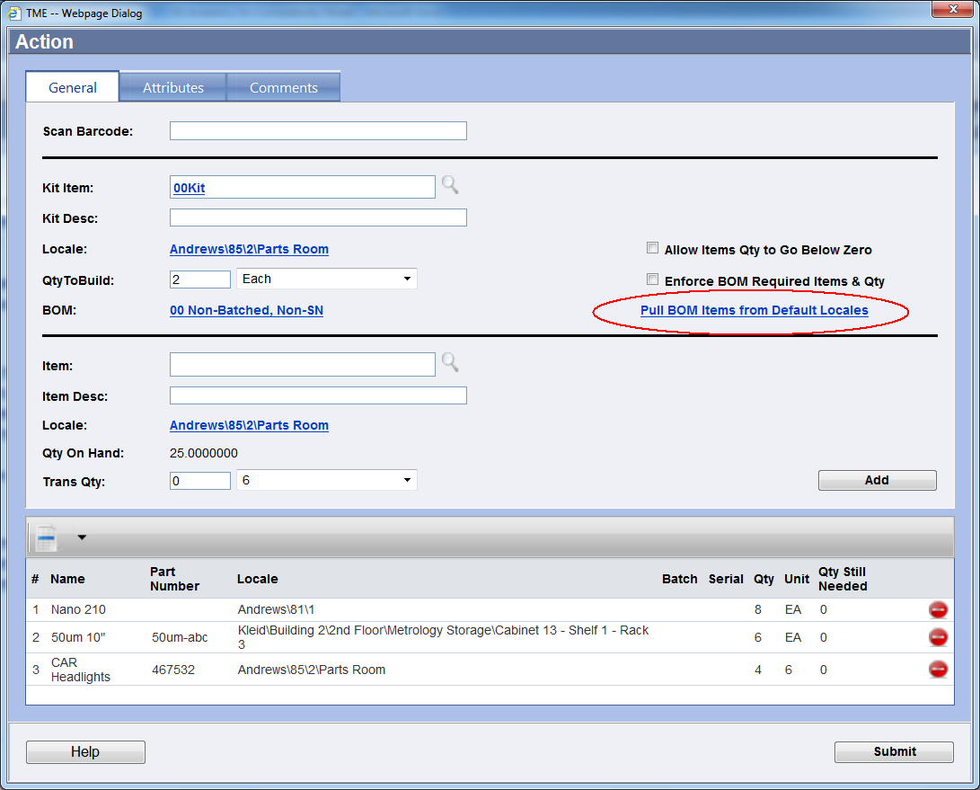
Figure 56 Build Kit Screen with BOM Items Automatically Pulled
If not using the Pull BOM Items from Default Locales and not using the Enforce BOM Required Items & Qty options:
Select each Inventory Item individually. Click on the to the right of the Item field. The Item LookUp screen will appear. Make the selection. The Locale will populate with the default Locale for the selected Item. Click on the Locale link to change. Input the Batch Number and/or Serial Number if applicable. Enter the Trans Qty and Unit of Measure and click on . As each Item is added to the list, the Qty Still Needed will update. However, since the enforcement of the BOM is not turned on, any Item can be added to the list, the Qty Still Needed will not be enforced and BOM Items (including those designated as Required on the BOM) can be left off. Repeat for all Items needed to build the Kit. Click on to complete the build.
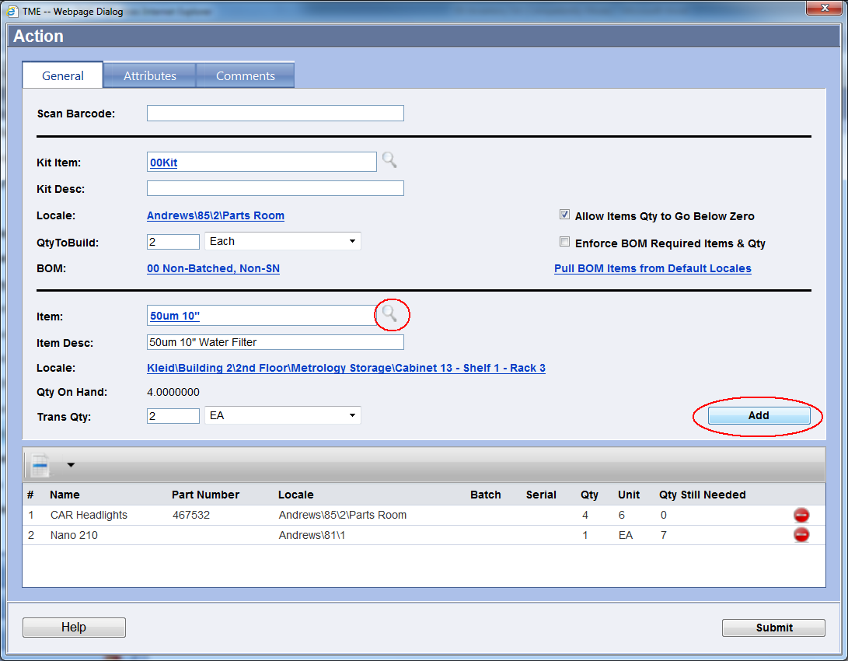
Figure 57 Build Kit Screen with No Enforcement or Automatic Pulling of Items
If not using the Pull BOM Items from Default Locales and are using the Enforce BOM Required Items & Qty options:
Select each Inventory Item individually. The Item field will convert to a drop down list of only those Items from the BOM. Select an Item from the drop-down list. The Locale will populate with the default Locale for the selected Item. Click on the Locale link to change. Input the Batch Number and/or Serial Number if applicable. As each Item is added to the list, the Qty Still Needed will update. However, since the enforcement of the BOM is turned on, the Build cannot be submitted until all Items designated as Required on the BOM with their designated quantities have been added to the list. Enter the Trans Qty and Unit of Measure and click on . Repeat for all Items needed to build the Kit. Click on to complete the build.
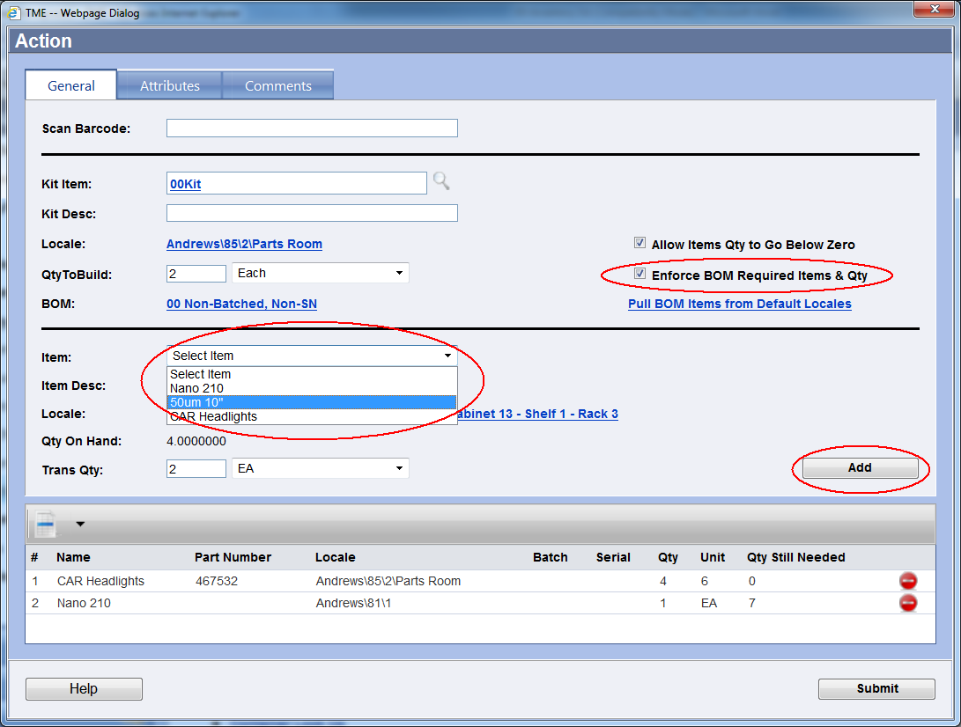
Figure 58 Build Kit Screen with Enforcement Option
Once submitted, the Build Kit screen will close. The Inventory Items and Kit quantities will be updated for their default/selected locales accordingly.

Exercise 12:
Adjust your Inventory Items so that you have at least 10 of each in two different locations. Verify quantities.

Exercise 13:
Place two Items into My Inventory.

Exercise 14:
Build two of your kits and one belonging to another User. Transfer to an alternate locale. Verify transactions.

